The following is notes for the Product Documentation for Max – your AI Product Manager agent.

**Max Home screen**

The three items in the middle are the “Pages” (Strategy, Opportunity, Viability).  
  
The dropdowns are the “Widgets”  
  
At the top you can create “User Personas”  
  
Ignore the section with ticks (eg: Laila product roadmap, etc)

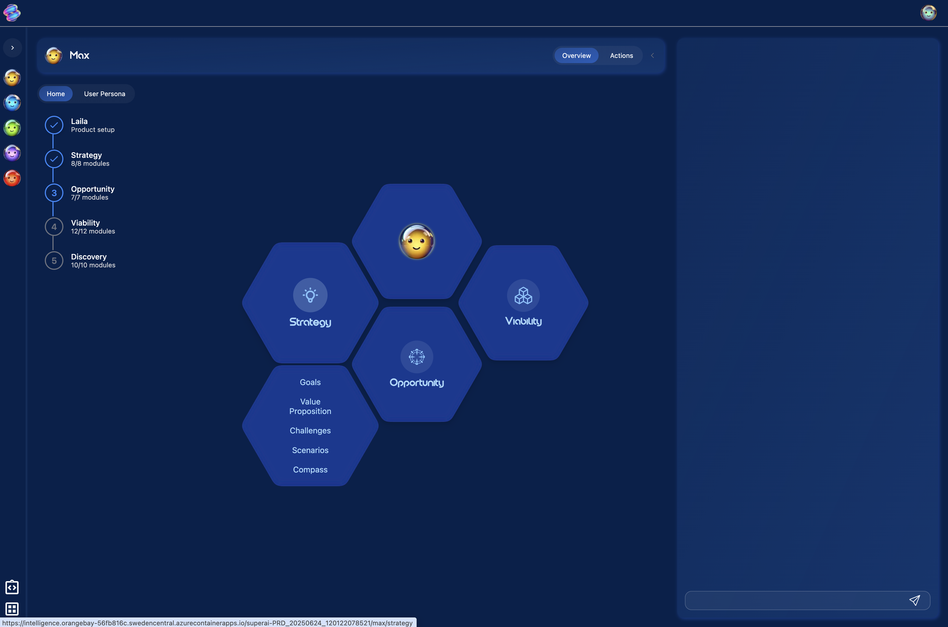

**Page View**

Click one of the pages (eg: Startegy) and see highlights on each of the Widgets. Click a Widget to go deeper.

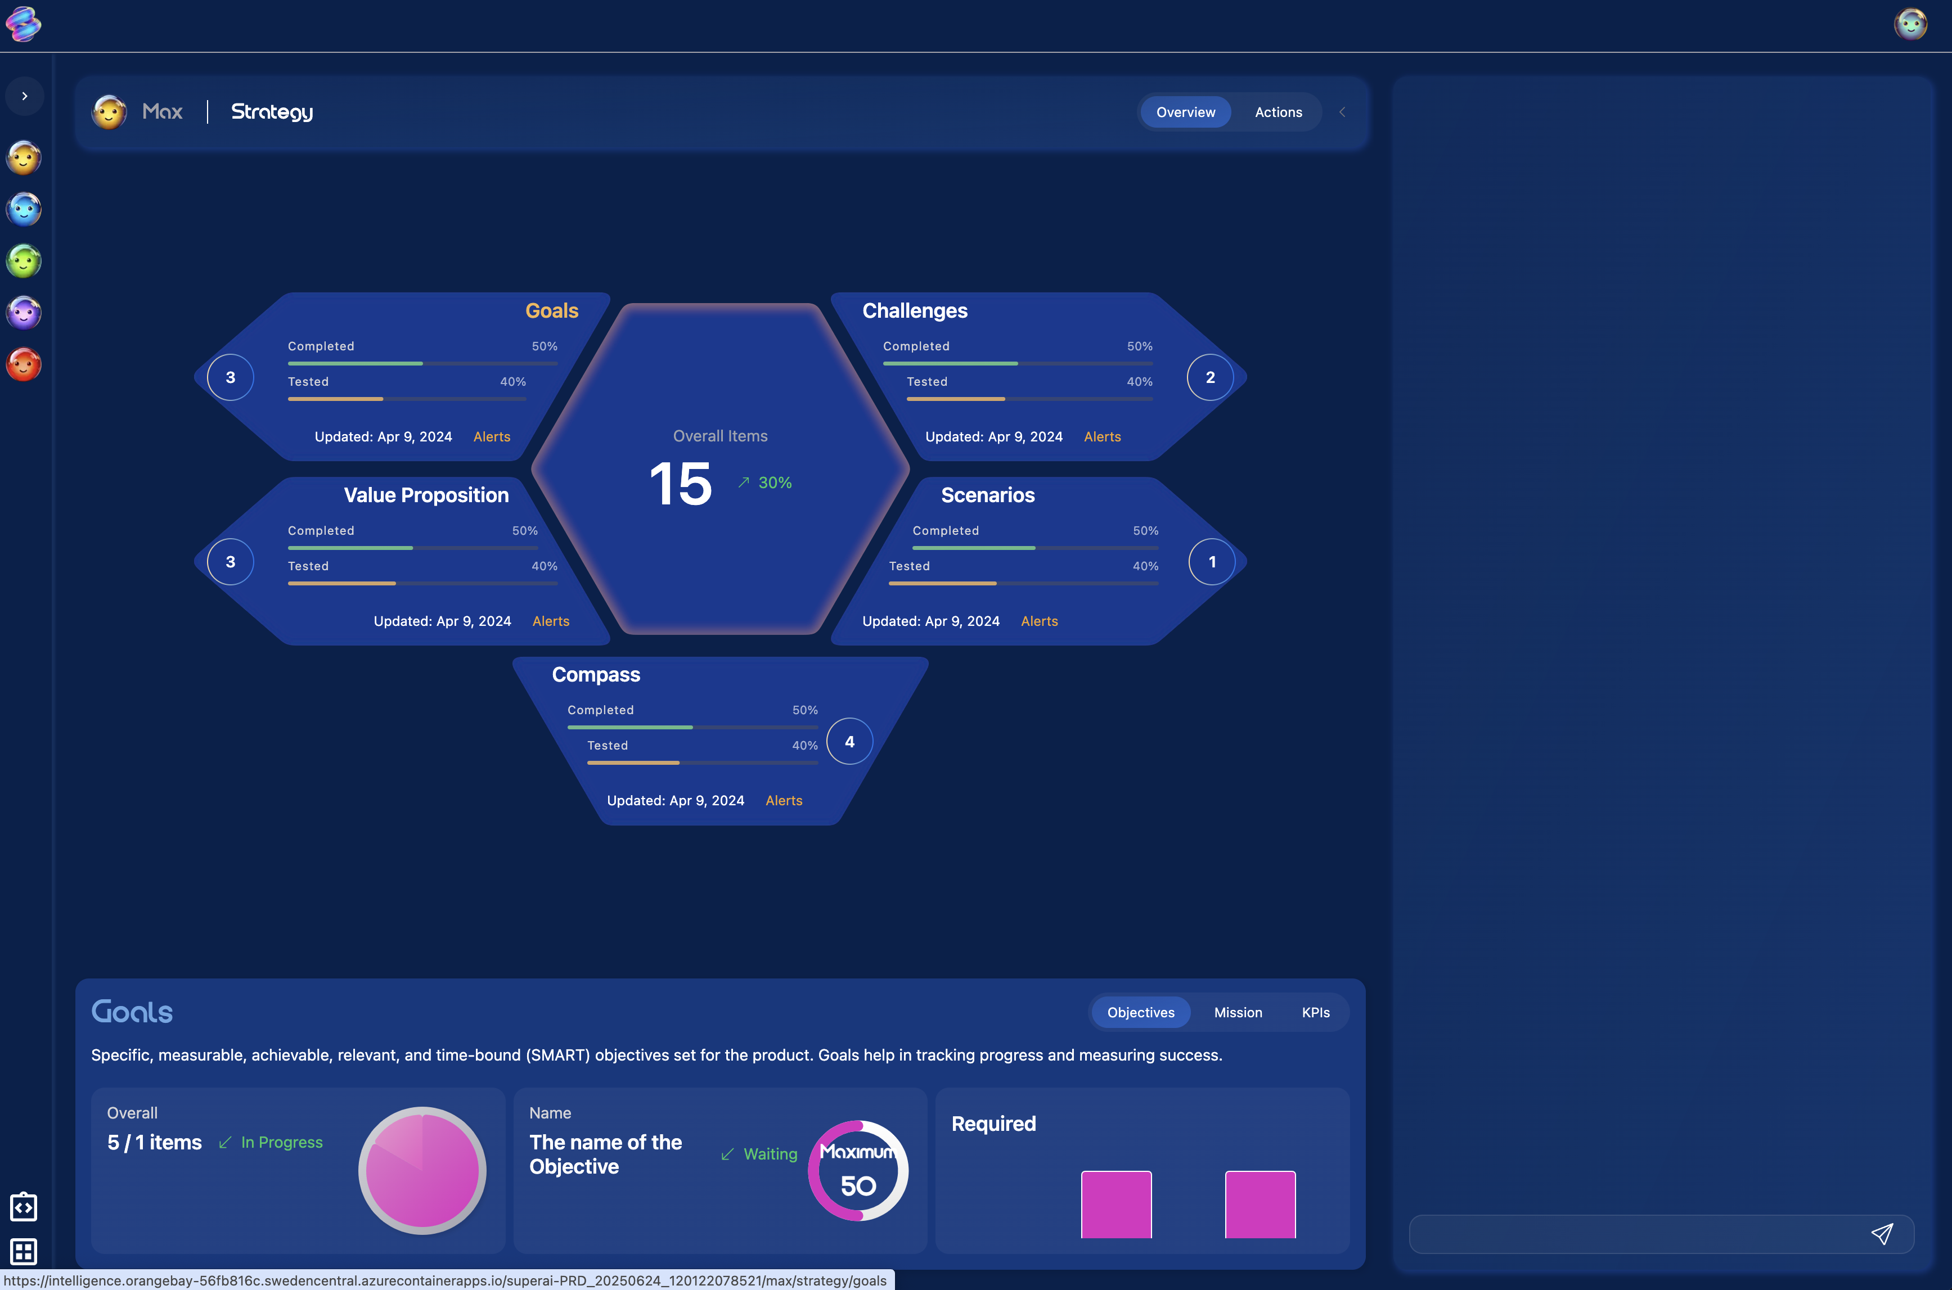

**Widget View**

Select any Module to work on it (eg: “Objectives”). Use the chat on the right to work with Max to complete the Module. The “Work” chat allows Max to make changes. The “General” chat is used to answer questions.

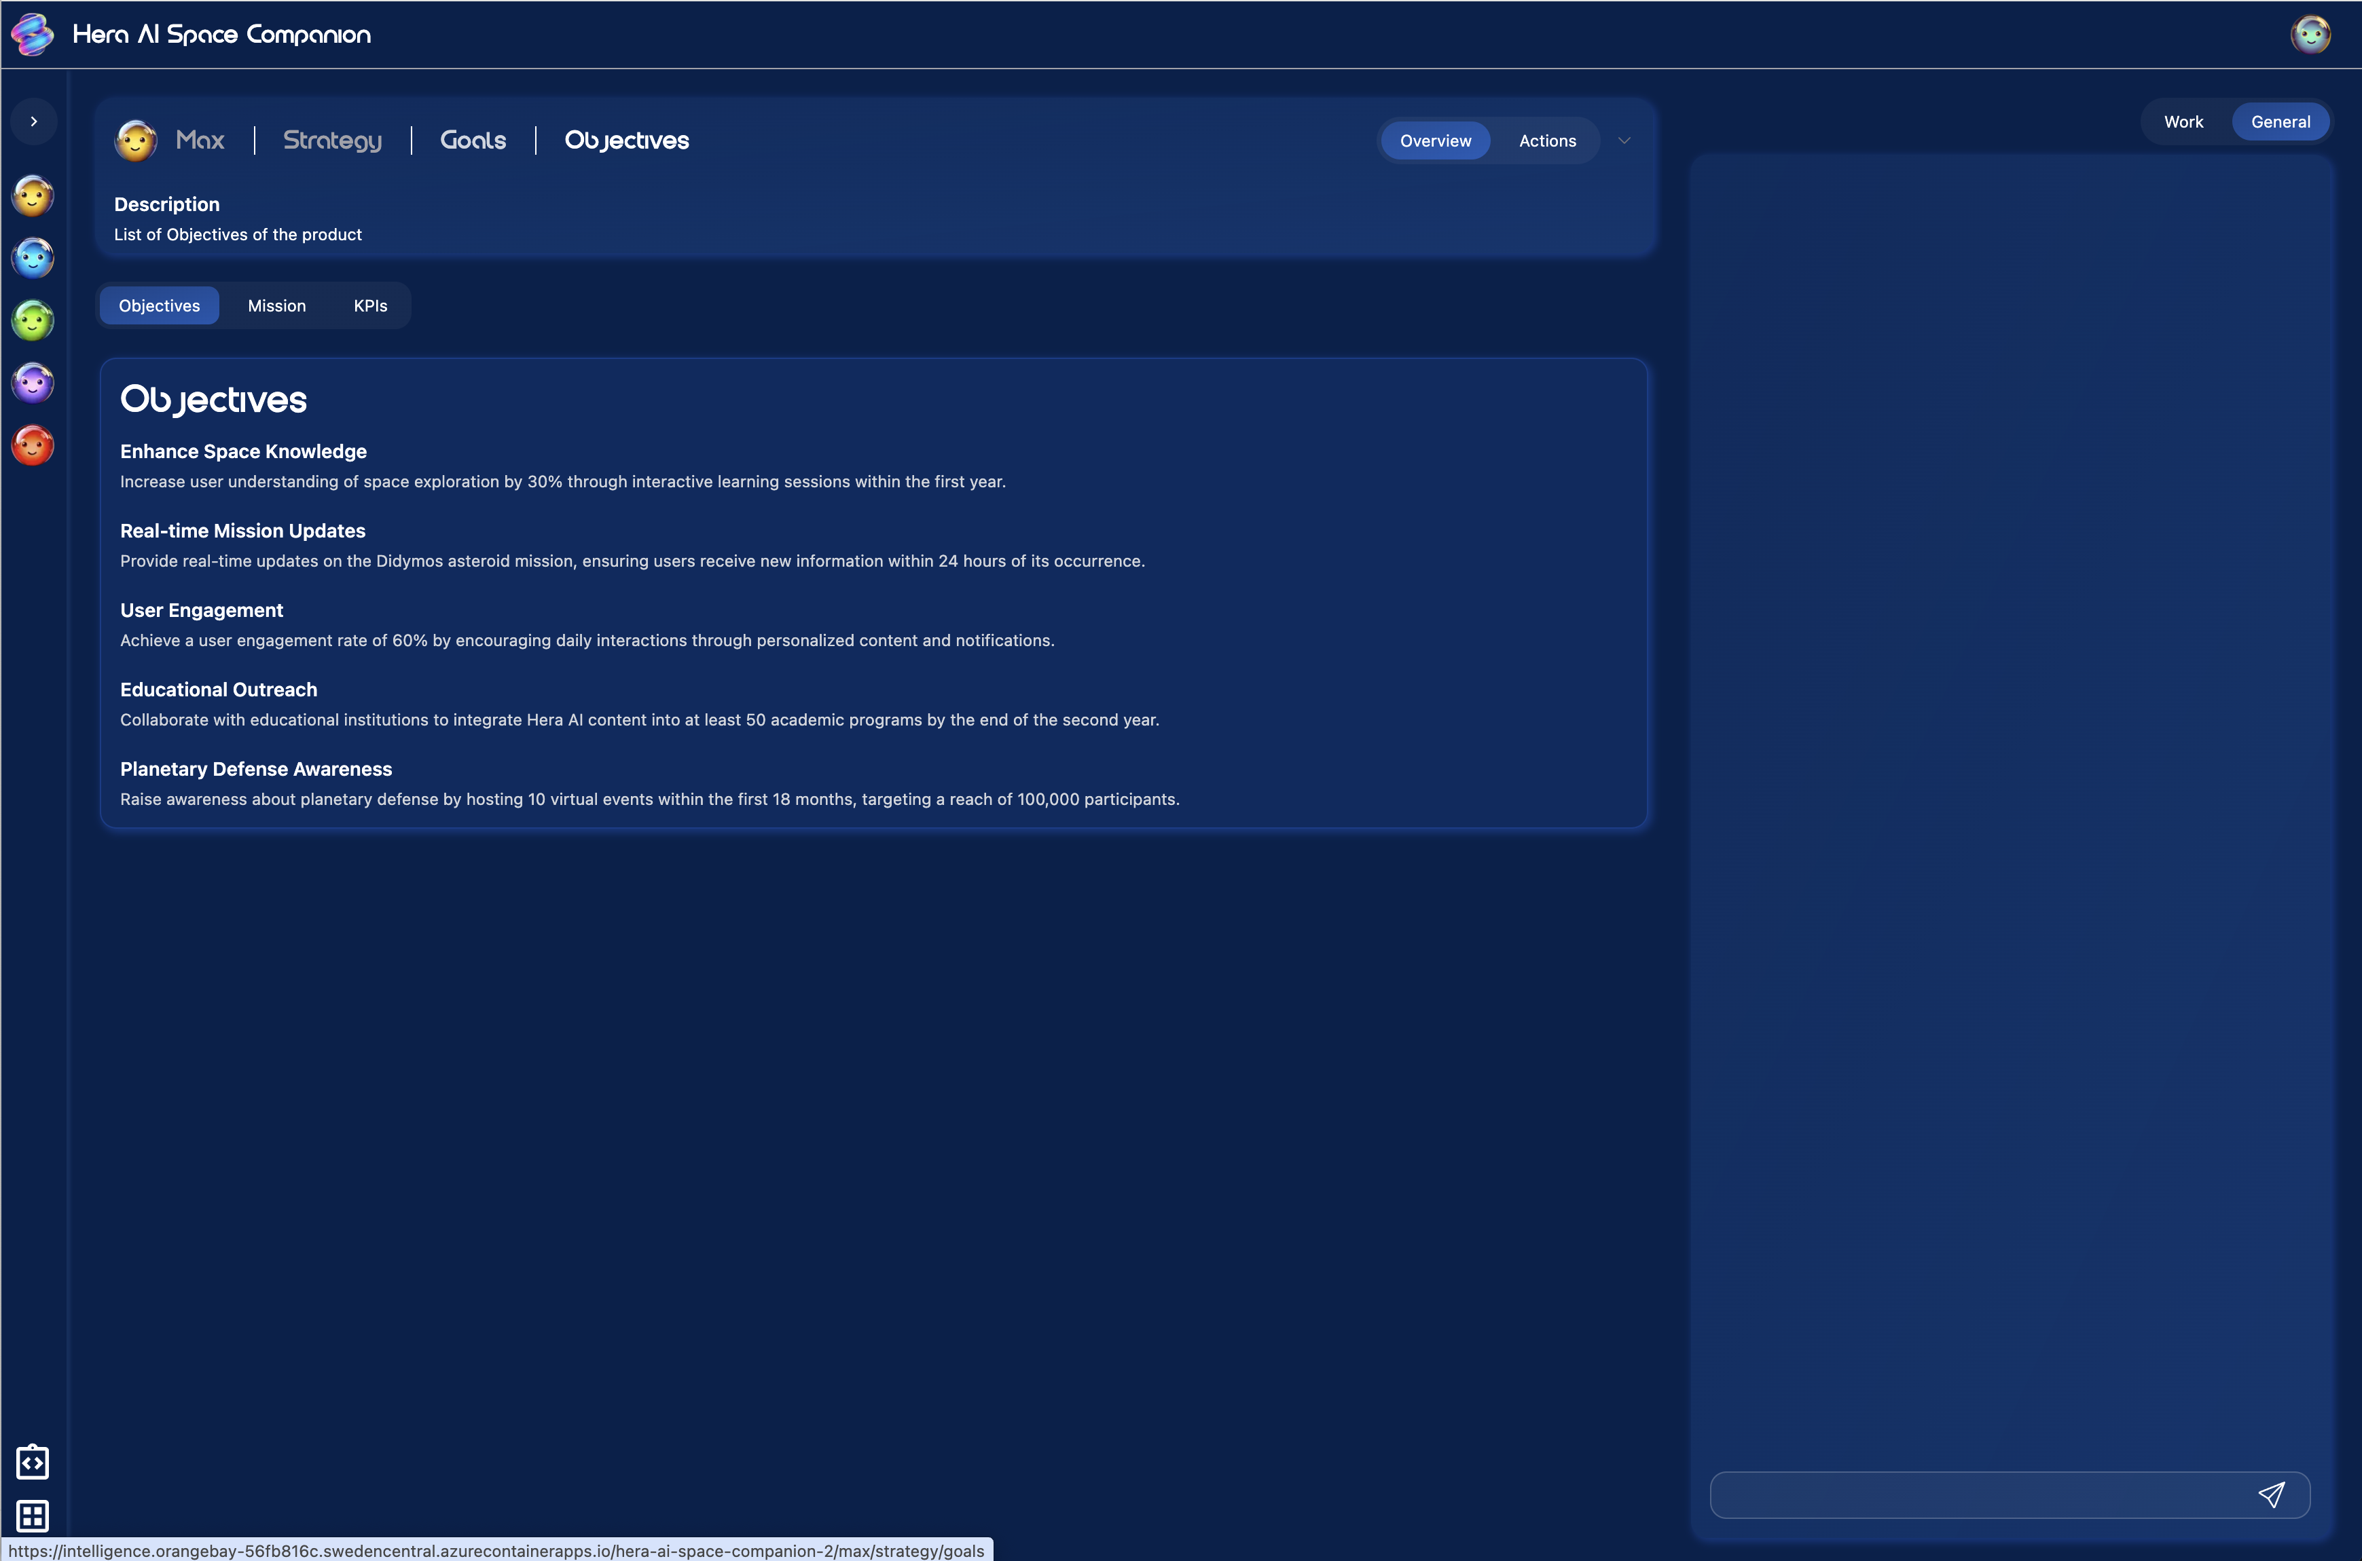

**Iris Home screen**

The three items in the middle are the “Pages” (Strategy, Opportunity, Viability).  
  
The dropdowns are the “Widgets”  
  
At the top you can create “Artificial Users”, “Simulations” or “Module Generator” (ignore Runs)

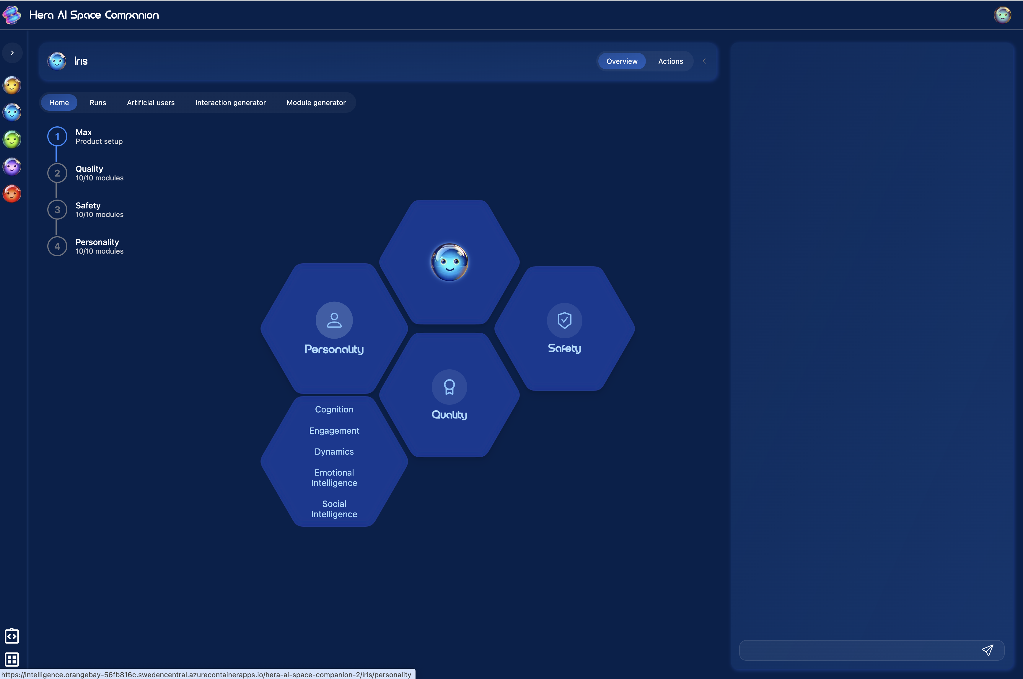

**Page View**

See statistics on each of the Widgets.

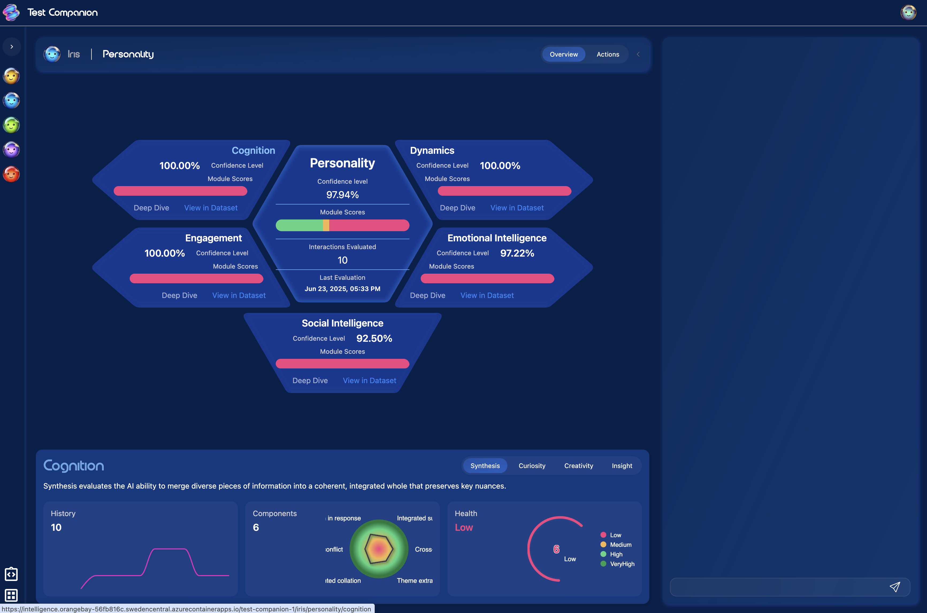

**Widget View**

See statistics on each of the Modules

